Lab 3 - Routing Protocol
NAME: POH LOK YEE
MATRIC NUM.: A23CS0262
SECTION: 12

INTRODUCTION
This lab looks into the network layer, focusing on subnetting and routing.

TOPOLOGY
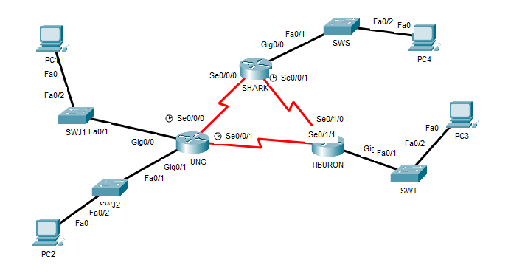

LAB INFORMATION
Here is some basic information for the lab. The network address given is 172.18.110.0/23.
Table 1

Device | Subnetwork | Usable Hosts
JERUNG | LAN1 | 20
 | LAN2 | 30
SHARK | LAN | 60
TIBURON | LAN | 50
K8Connections | JERUNG-SHARK | 2
 | JERUNG-TIBURON | 2
 | SHARK-TIBURON | 2
=

Table 2

# | Device  Name | Interface | IP Address | Subnet Mask | Gateway
1 | JERUNG | Se0/0/0 | 172.18.110.193 | 255.255.255.252 | -
2 |  | Se0/0/1 | 172.18.110.197 | 255.255.255.252 | -
3 |  | G0/0 | 172.18.110.129 | 255.255.255.224 | -
4 |  | G0/1 | 172.18.110.161 | 255.255.255.224 | -
5 | TIBURON | Se0/1/1-b | 172.18.110.198 | 255.255.255.252 | -
6 |  | Se0/1/0 | 172.18.110.202 | 255.255.255.252 | -
7 |  | G0/0 | 172.18.110.65 | 255.255.255.192 | -
8 | SHARK | Se0/0/0 | 172.18.110.194 | 255.255.255.252 | -
9 |  | Se0/0/1 | 172.18.110.201 | 255.255.255.252 | -
10 |  | G0/0 | 172.18.110.1 | 255.255.255.192 | -
11 | PC1 | - | 172.18.110.158 | 255.255.255.224 | 172.18.110.129
12 | PC2 | - | 172.18.110.190 | 255.255.255.224 | 172.18.110.161
13 | PC3 | - | 172.18.110.126 | 255.255.255.192 | 172.18.110.65
14 | PC4 | - | 172.18.110.62 | 255.255.255.192 | 172.18.110.1

LAB TASKS

Task 1 – IP Addressing
- Given the network address of the organisation and the basic information provided in both Tables 1 and 2. Show your workings here and complete Table 2 with the correct information. PCs will be given the last usable address of the subnetwork.
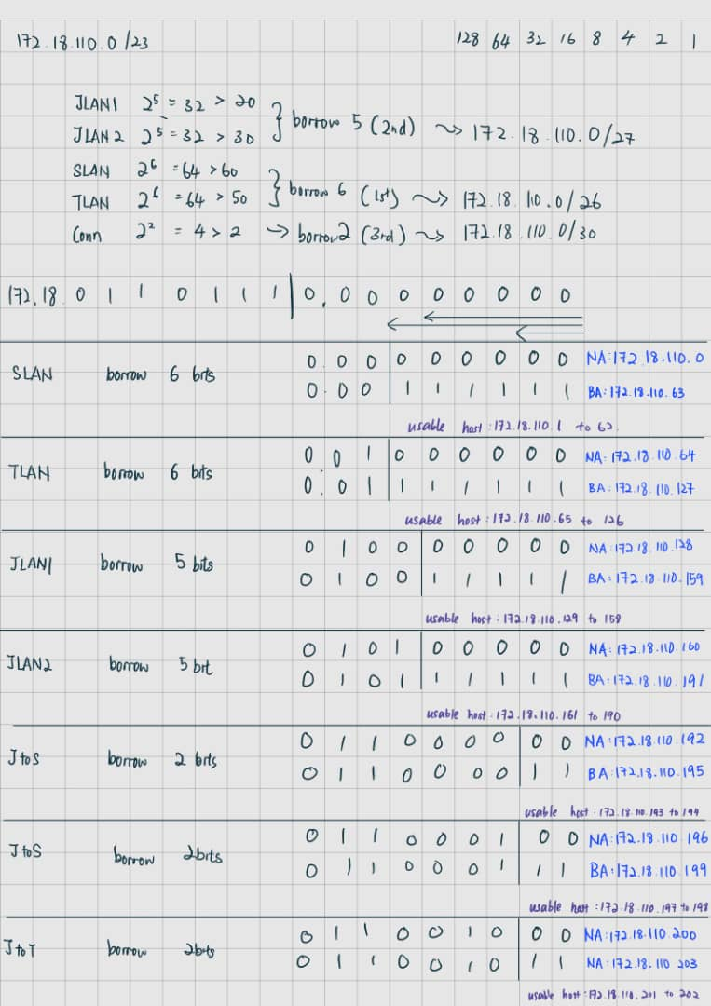

- Using the IP addresses calculated, configure the devices with the appropriate information.

Task 2 – Routing Table
- Paste the current routing table of each router here. There are 2 ways to this – via CLI and via Packet Tracer (PT) tool. Use both ways to show the routing table of all the routers.
  - CLI
    - Click on a router. In the prompt, type show ip route. The routing table of the router will be shown, as shown in Figure A.
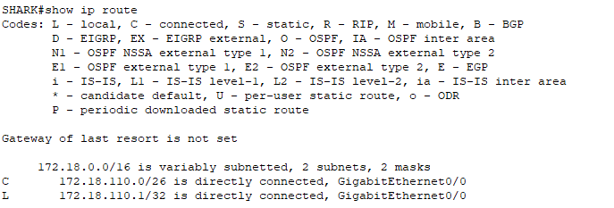
Figure A

JERUNG：
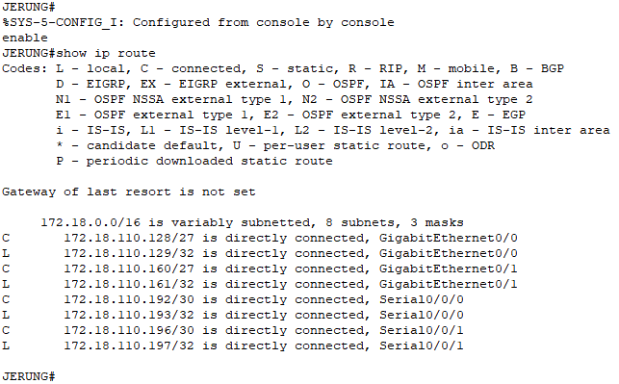
TIBURON：
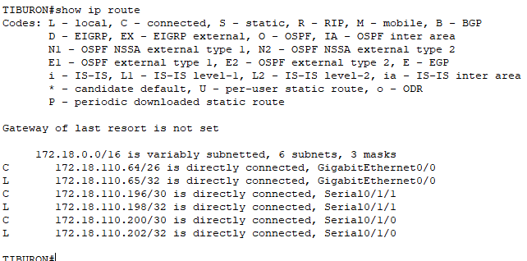
SHARK：
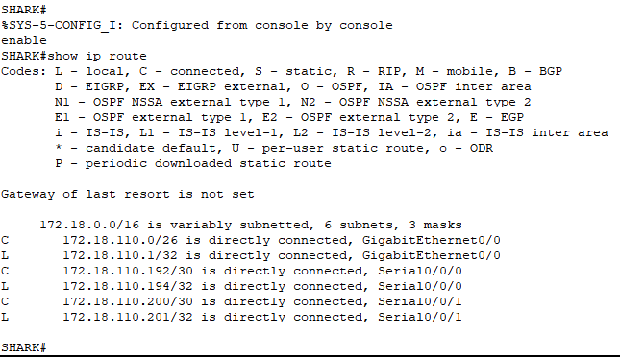

Jerung

  - PT tool
    - Click on the magnifying glass (shown in Figure B), then click on a router, then choose Routing Table. A sample of the result is shown in Figure C.

Figure B
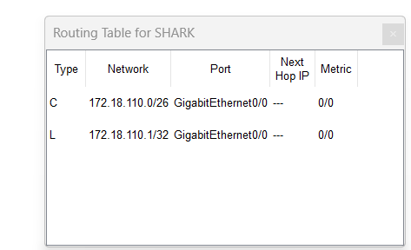
Figure C
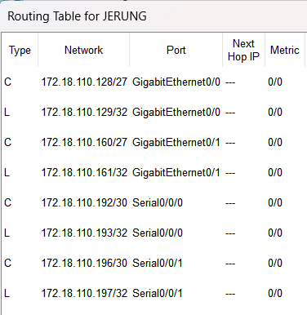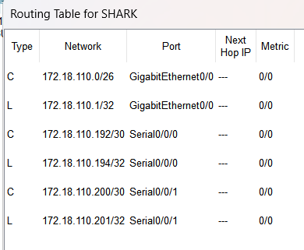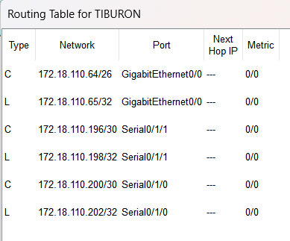
- Try to ping PC2 from PC1, paste the results here.
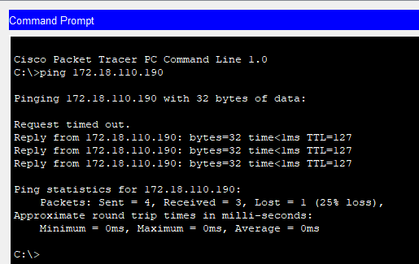
Success
- Try to ping PC4 from PC1, paste the results here. 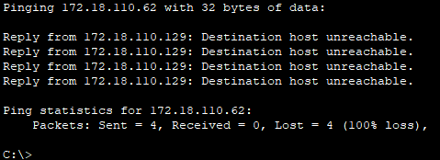
Failed
- Explain the reason(s) behind the results.
PC2 ping from PC1 successfully as they are in a same subnet and router. PC4 cannot ping from PC1 as they are not in a same subnet and router. Different router cannot communicate with each other. The network between them are not configure.
- What needs to be done to ensure all PCs can ping each other successfully?
The router must be properly configured to interconnect all network segments for ensuring a seamless routing path for traffic between the PCs.

Task 2 – Routing Configuration
- Let’s start by opening the routing table (using the PT tool) for TIBURON and JERUNG. This is done to show changes to the routing table as configurations are made.
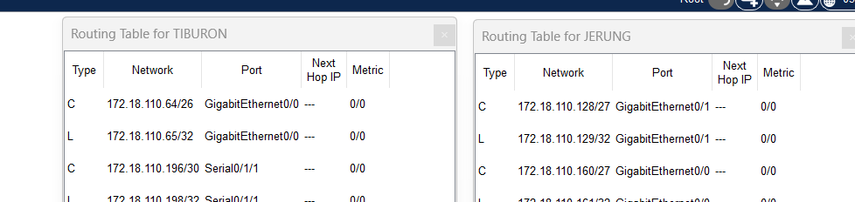
Figure D
- In router JERUNG, configure the RIP routing protocol as shown in Figure E.
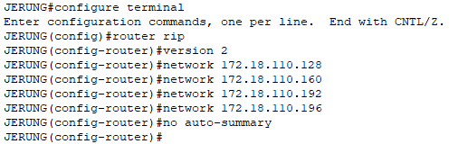
Figure E
  - What can you say about the addresses used in the ‘network’ instructions in Figure E?
The addresses used are all network address (NA) of router JERUNG’s. They act as the router information (self-contained network) of JERUNG.
- Then configure RIP in TIBURON. All are similar except use the network address. Use the instructions as shown below.
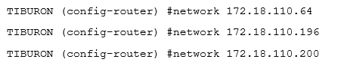
- As you may have seen, there are changes in the routing tables of both TIBURON and JERUNG. Paste a copy of these routing tables here
JERUNG:
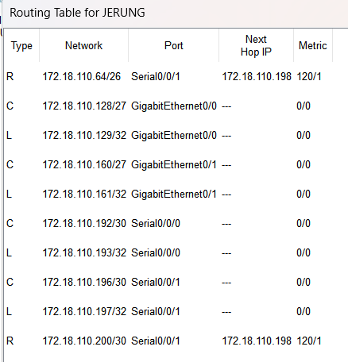
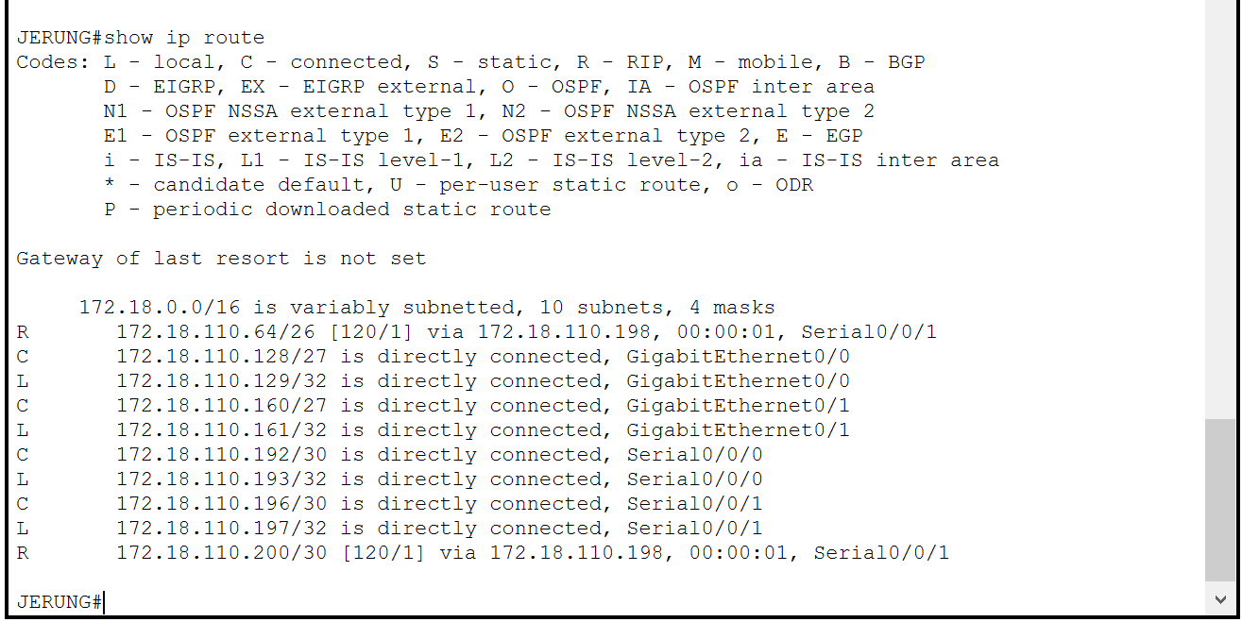

TIBURON:
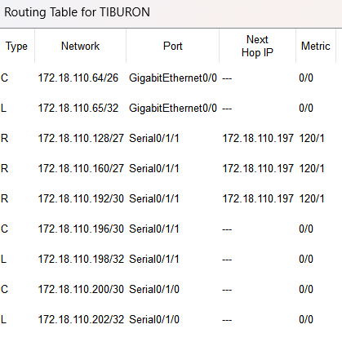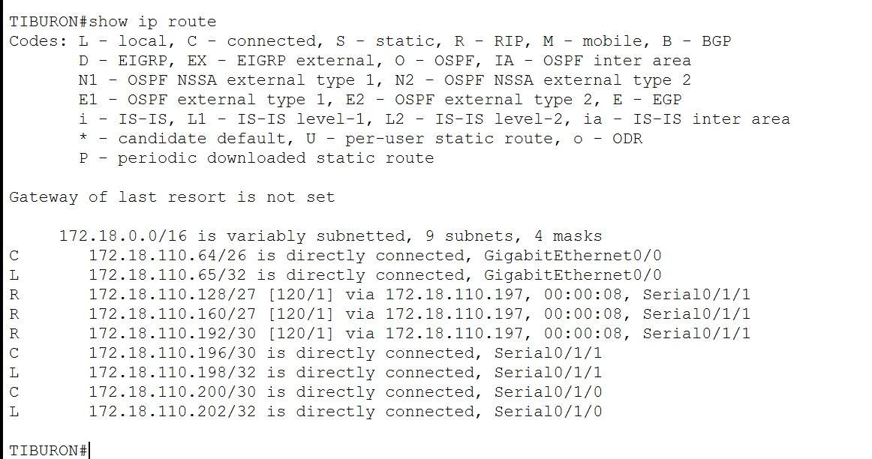
  - What are the changes seen in TIBURON?
A new route generated by the RIP protocol shown in the routing table and marked with an “R” which stands for RIP.

  - What are the Networks with type R in TIBURON and JERUNG?
JERUNG:
- 172.18.110.64/26
- 172.18.110.200/30
TIBURON:
- 172.18.110.128/27
- 172.18.110.160/27
- 172.18.110. 192/30

  - Ping PC3 from PC1. Was it successful?

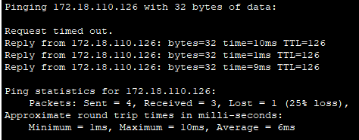
Success

  - Ping PC4 from PC1. Was it successful?
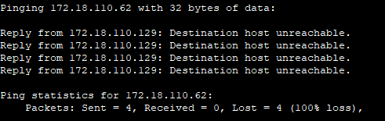
No. It failed

  - Explain the reasons for your answer.
PC1 pings PC3 successfully as both are in the same subnet and they are directly connected to JERUNG, the network between them is correctly configured. The RIP routing protocols on JERUNG(PC 1) and TIBURON(PC 3) have been automatically updated in the routers’ routing tables.

PC1 fail to pings PC4 due to an improperly configured network connection and the absence of a set route. Additionally, the RIP routing protocol and routing table on SHARK (for PC4) have not been configured correctly.

  - Continue with configuration of RIP in SHARK. Paste your configurations here.
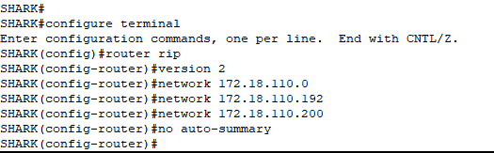

  - Open router SHARK’s routing table and paste here.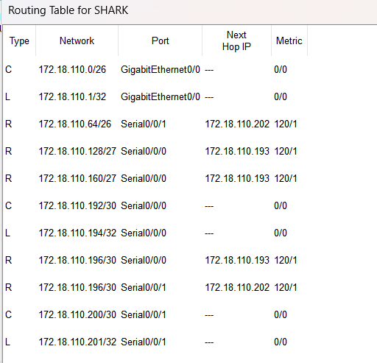
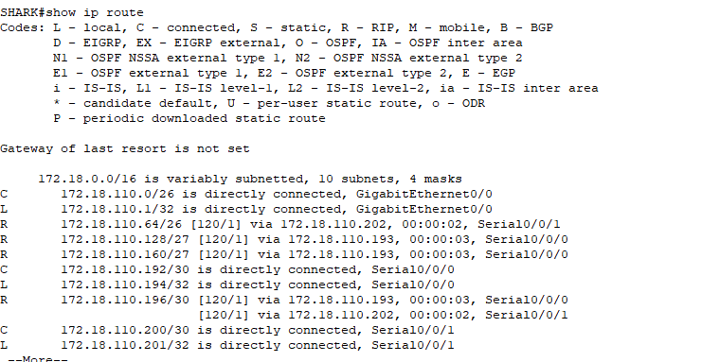

  - Try to ping from PC4 to all other PCs in the topology. *Note: Try to ping at least twice to get best results.
PC | Ping result
1 | 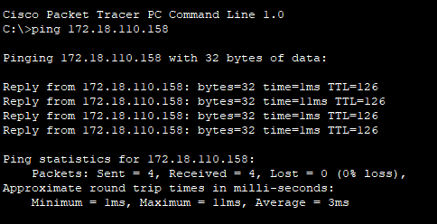
2 | 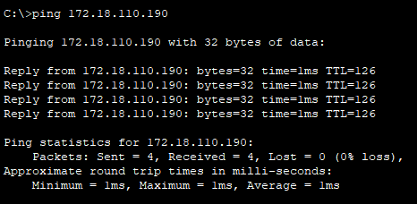
3 | 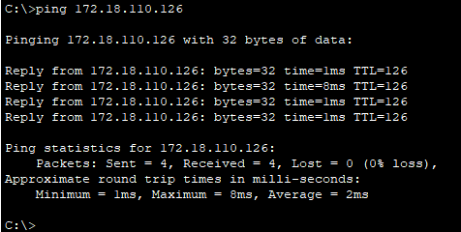

Task 3 – Routing Update
- Let’s try a little experiment. Change the IP addresses of router TIBURON interface G0/0 to 192.168.1.1/24.
  - This means that the subnet has changed. Find the new Network address of this subnet. Network Address is: 192.168.1.0/24
  - As this change happens, PC3 must also have different IP address, subnet mask and gateway address. What will it be?
PC3 | Info
IP address | 192.168.1.254
Subnet Mask | 255.255.255.0
Gateway Address | 192.168.1.1

  - After this change, can PC4 and PC1 ping PC3?
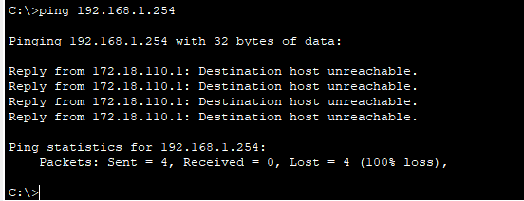
PC4 ping PC3 is failed.

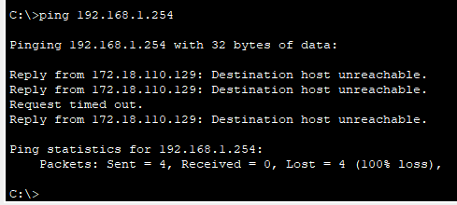
PC1 ping PC3 is failed.

  - Copy and paste the routing tables for both SHARK and TIBURON here.
TIBURON:
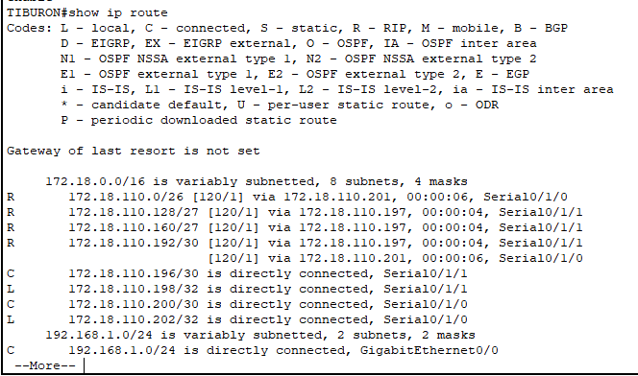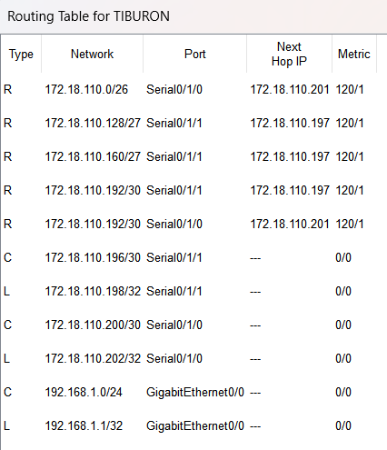

SHARK:
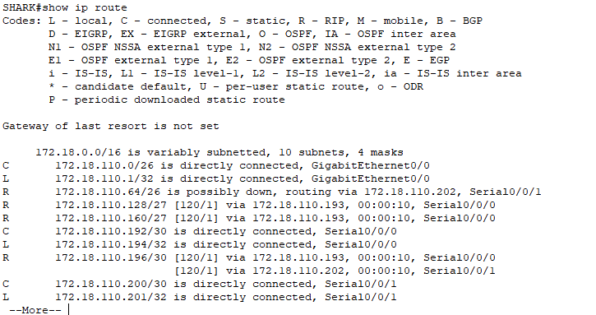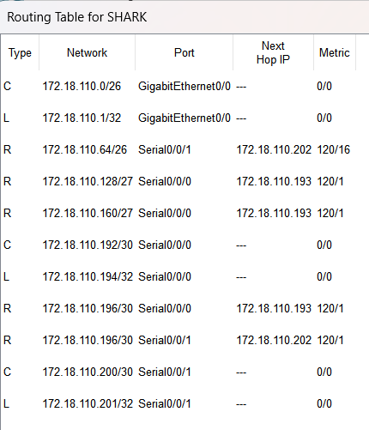
  - Referring to the routing table, explain your findings.
The routing table has not been updated with the new network address of the subnet. Packets intended for PC3 are dropped, leading to failed ping attempts from PC4 and PC1 to PC3 after the IP address change.
  - What is your next move to ensure end-to-end connectivity (i.e. all PCs can ping each other successfully)?
Update the routing configurations on TIBURON to include the new subnet (192.168.1.0/24) and enable its advertisement through the RIP protocol. This will ensure the subnet is automatically propagated and updated in TIBURON’s routing table, enabling connectivity between all PCs.

  - Show your configurations in TIBURON to ensure end-to-end connectivity.
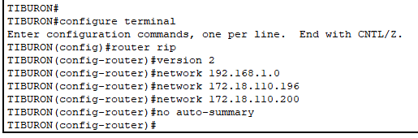
  - To ensure end-to-end connectivity, ping to all the PCs from PC3.
PC | Ping result
1 | 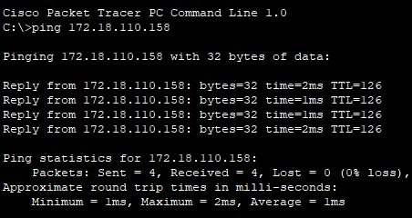
2 | 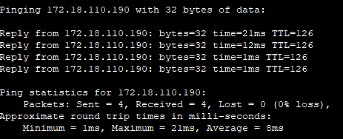
4 | 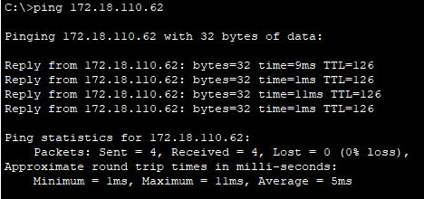

REFLECTION
What have you learned in this task?

In this lab, I developed a comprehensive understanding of subnetting and routing protocols. I gained practical experience in configuring IP addresses, subnet masks, and gateways to ensure device connectivity. Troubleshooting connectivity issues emphasized the need to verify routing configurations and propagate routes effectively. The use of Packet Tracer tools allowing me to visualize and optimize network topologies. This lab significantly enhanced my skills in network design and troubleshooting.

